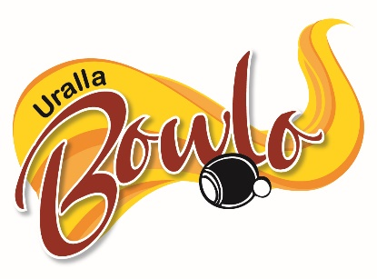
Uralla Bowling & Recreation Club Ltd
52 Hill Street | PO Box 4 P: 02 6778 4192
URALLA NSW 2358 E: manager@urallabowlo.com.au
President: Allan Rummery Secretary/Manager: Helen Avery

Application for Membership
Personal Details – All questions must be answered
Full Name:
Address: Suburb: Postcode:
Postal Address: Suburb: Postcode:
Phone: Mobile: Email:
Date of Birth: / / Occupation: Signature:
The following information is also required
I allow Uralla Bowling & Recreation Club Ltd to use the above information for marketing (This information will not be provided to a third party unless required by law) YES/NO
If Yes, I wish to receive marketing information by (please tick) Surface Mail
More than one may be ticked
Email SMS
The Corporations Act allows members to opt out of receiving notices of meeting and annual reports by surface mail, and members may elect to access this information electronically. Do you wish to access such information electronically? YES/NO
Privacy Statement
The above information is required to comply with Section 15.4 of the Constitution of Uralla Bowling & Recreation Club Ltd, and the Registered Clubs Act 1976. Unless indicated above this information may be used for marketing by Uralla Bowling & Recreation Club Ltd. This information will not be disclosed to any other party unless required by law and will be treated in confidence.
In making this application I agree to be bound by the Constitution of Uralla Bowling & Recreation Club Ltd, and its By-Laws. In addition I understand Uralla Bowling & Recreation Club Ltd adopts Responsible Service of Alcohol and Responsible Gambling Policies. To this I agree to abide by the House Policy of Uralla Bowling & Recreation Club Ltd, and follow any reasonable instruction from staff in implementing this policy. Furthermore, I understand that my failure to abide by these policies may result in the Board of Directors pursuing disciplinary action.
This application needs to be endorsed by a nominator and seconded. Both these persons are to be financial members of 12 months standing of Uralla Bowling & Recreation Club (Staff cannot nominate or 2nd this application)

I, , wish to nominate the above mentioned person for membership to Uralla Bowling & Recreation Club Ltd
Signed: Member No. Date: / /

I, , wish to second this nomination for membership to Uralla Bowling & Recreation Club Ltd
Signed: Member No. Date: / /
Office Use Only
Paid $ Date: / / Receipt No:
Member Number Allocated: Number of Years:

